SUTTON
PARISH COUNCIL
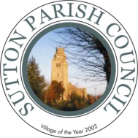
Statement of Intent
For
Community Engagement

Adopted: 14th September 2010
Reviewed:

Sutton Parish Council
The Glebe
4 High Street
Sutton
Cambs
01353 777189

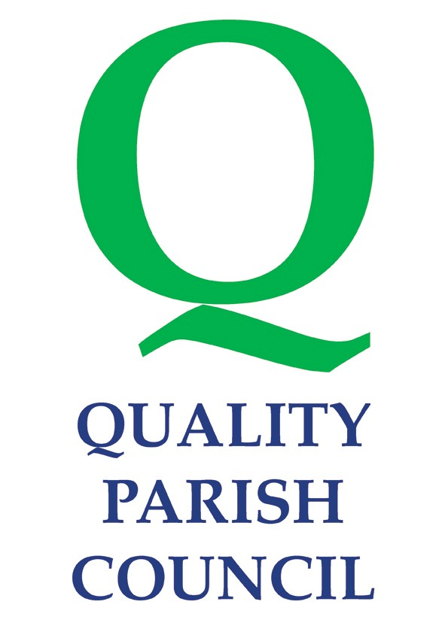
1.0 Introduction

The ‘power of well-being’ is the informal name given to the statutory power enabling a local authority to do anything which it considers likely to achieve the promotion or improvement of the economic, social or environmental well-being of their areas.

The Local Government Act 2000 (s2) was amended by the Local Government Involvement in Health Act 2007 (s77) to give the power to eligible councils. If a council meet the criteria then it can use the power rather than the current Local Government Act 1972 (s137)

The Statement of Intent for Community Engagement has been prepared in accordance with the ‘Power of Wellbeing’.

2.0 Policy Statement

Ensure that through the use of a wide range of approaches to public consultation and community engagement residents are actively encouraged to input into decisions that affect their day to day lives in the parish.

3.0 Defining the Community

The parish of Sutton is situated 6 miles west of the Cathedral City of Ely, in the Cambridgeshire fens. It comprises of Sutton and the hamlet of Sutton Gault with just over 4100 residents (June 2023).

The principal authorities serving Sutton are:-

- Cambridgeshire County Council.
- East Cambridgeshire District Council

The community may be defined as consisting of:

- Residents of the Village,
- Users of Parish Council Services,
- Head Teacher staff and Governors of Sutton Primary School,
- Young people who live and/or go to school in the Village,
- Retail and other Businesses in the community, including employees,
- Interest groups – clubs and societies e.g. Brownies, Scouts etc
- Voluntary organisations,
- Religious Groups,
- Farming Community,
- Groups of people defined by a common factor such as age, disability,
- and other groups,
- Councillors and public service representatives and Council Staff.

4.0 Role of Council Members and Officers

The Parish Council consists of 15 Councillors elected by the community or co-opted by the Parish Council. Councillors work on behalf of the Community in a voluntary capacity, and are encouraged to attend training to enhance their role. Councillors have the opportunity sit on a number of committees of the Parish Council

- Planning
- Highways and Conservation
- Community Services
- Finance
- Administration
- Burial Ground and Allotment
- Newsletter and PR

5.0 Provision of Information to the Community and Opportunities for Community Involvement

- The Parish Council Office and Information Centre are open to the public Mondays to Thursdays from 10am to 12. Other times by appointment with the Parish Clerk.

2. The list of Councillors contact details is available on the notice board, website and in the Annual Report.

- The Parish Council website (www.sutton-pc.co.uk) contains information regarding the work of the Council, including meeting agendas and minutes, policy documents, financial statements, annual report and contact details.

- The Parish Council produces a newsletter on an annual. This is delivered free to every household in the parish. The PC also update monthly in he Local Newsletter on a monthly basis and contribute to it financial needs.

- Information is published on the 2 notice boards in the parish, and in the Information Centre, at The Glebe.

- The Parish Council produces a Welcome Pack for new residents, which is available from the Information Centre, at The Glebe.

7. The Annual Report is prepared and available on the Parish Council website or by Hard Copy from the Parish Council office.

- The council has supported and been part of the production of the
Parish Plan.

- The council undertakes consultations by questionnaire or public meetings as appropriate, for specific issues.

6.0 Involvement with Partnerships

The council has representation on the following:-

- Ely & District Citizens Advice Bureau
- East Cambridgeshire Neighbourhood Panel
- Cambridge and Peterborough Association of Local Councils
- Sutton Poors’ Land Charity

The council subscribes to the following bodies to enable it to meet current legislation, new services, health and safety requirements, and for support on a day-to-day basis:-

- Cambridgeshire and Peterborough Association of Local Councils
- Society of Local Council Clerks
- Cambridgeshire ACRE
- Institute of cemeteries and crematoria
- Local Council Advisory Service

7.0 Objectives
- To work more closely with residents, businesses and community groups and to respond to their needs.
- To engage with as many people as possible who want to participate in the decision making process.
- To monitor services and planning for the future;
- To ensure, that, through the use of a wide range of approaches to public involvement and community engagement, we actively encourage the involvement of residents, to capture their views and learn their concerns and effectively use those views as an integral part of the decision-making process.
- To ensure that residents have opportunities to be heard at appropriate stages of Parish Council decision making, and the capacity to be effective citizens.

8.0 Action Plan

Sutton Parish Council will:-

1. Deliver its services to the highest quality in terms of efficiency effectiveness, in terms of value for money.

2. Conduct its business openly and democratically, and will consult with
local people and adopt majority views at every practical opportunity.

3. Consider good practice from other similar sized Parish Councils.

4. Examine and challenge through periodic reviews how a service is delivered.

5. Maintain its use of open and fair competition, where practical, when
considering tenders and the provision of services.

6. Comply with the National Code of Local Government Conduct regarding standards in public life.

7. Act in the best interests of local people in making appropriate representations to:

a) Central Government
b) Cambridgeshire County Council
c) East Cambridgeshire District Council
d) Other appropriate private, voluntary and public sector groups.
The council recognises that there are different levels of engagement and that involvement can be in one of the following five ways:

- Inform We tell people about our services
- Consult We ask people for their views via surveys and other methods and seek to adopt those supported by a clear majority.
- Involve We discuss what the issues and priorities are
- Collaborate We work together to improve and design new services
5. Empower We maintain an equal and effective working relationship

9.0 Outcomes we hope to achieve

Outcomes of the strategy will include:

- Improved communication through the establishment of new channels of engagement.
- More residents understanding the role of the Parish Council and being able to influence its activities.
- Improved engagement with local communities, with more people empowered to be involved in decision-making and a higher percentage of people involved in volunteering.
- Improved satisfaction with local public services.

