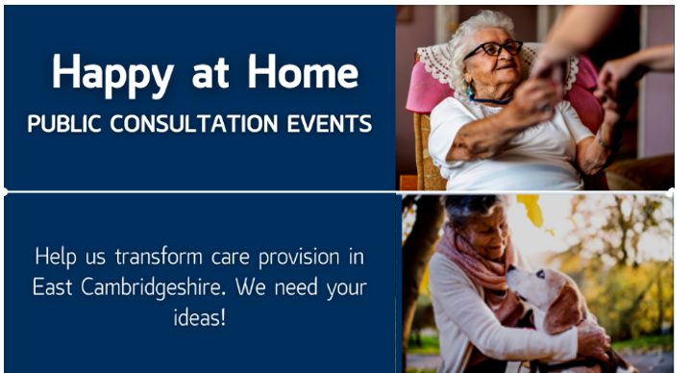
Happy at Home, initially working with communities in East Cambridgeshire, aims to help people living at home understand what help and support services are available in their local area and how to access these should they wish to.
Co-Creation Events
Happy at Home will support people to fulfil their wish to remain living at home for longer, enjoying a good quality of life and wellbeing.
We need you, our residents to help us. We want to create this together – starting with friendly, informative events where we will listen and build our plans with you. Everyone is welcome.
Happy at Home’s ambition is to deliver the following things across East Cambridgeshire:
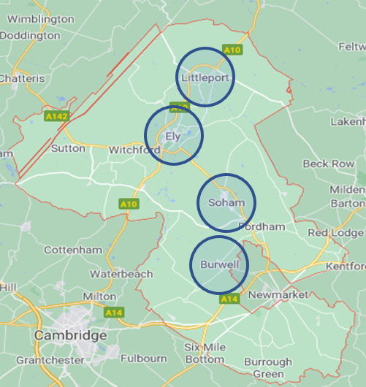
- Listen to local people and services to design a system together that makes it easier to access support when people need it
- That more people fulfil their wish to remain living at home for longer, enjoying a good quality of life and wellbeing
- Provide more information as to what services are available in the local community to support people
- Give people more choice of local support and more options for paying for help and support if they are unable to manage this themselves
- Support people to be as independent and happy in their own home as possible
If you, or anyone you know would like to attend any of the events detailed below and join the conversation, you will be very welcome.
First Round of Events:
Monday 13 September, 19:00-21:00 Littleport Village Hall, CB6 1GZ
Tuesday 14 September, 19:00-21:00 Mandeville Hall, Burwell, CB25 0BU
Wednesday 15 September, 19:00-21:00 The Maltings, Ely, CB7 4BB
Scan the QR code below for further information on Happy at Home and instructions and Microsoft Teams link to attend any of the virtual sessions at the venues listed:
Thursday 16 September, 14:30-16:30 Virtual Event (scan the QR code)
Friday 17 September, 19:00-21:00 Soham Pavilion, CB7 5ED
Second Round of Events, including feedback from the earlier sessions.
Tuesday 5 October, 19:00-21:00 Mandeville Hall, Burwell, CB25 0BU
Wednesday 6 October, 19:00-21:00 Soham Pavilion, CB7 5ED
Friday 8 October, 19:00-21:00 Littleport Village Hall, CB6 1GZ
Tuesday 12 October, 19:00-21:00 The Maltings, Ely, CB7 4BB

