East Cambs Local Engagement Event | Feedback Summary
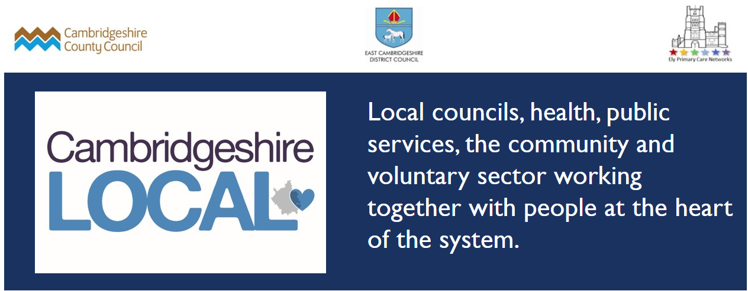

Hosted by Cambridgeshire County Council in partnership with East Cambs District Council and Ely North & South Integrated Neighbourhoods.

Our Aim
To begin a conversation about how we (public, community, and voluntary sector, and hopefully in future private sector) can collaborate to support people to be happy and healthy within interconnected places,
We shared some data and thematic concerns that we were hearing from communities and asked if this resonated with attendees, and how we could work together to build on community strengths in future. The slides from the event can be seen here

Attendance
In total 52 people attended the two events which were held on Zoom. The attendees included 14 parish councillors, six County and District councillors,12 representatives of voluntary and community sector, 9 county and district officers and five health colleagues.
Unfortunately, there was a clash with a key district council meeting, this will be avoided in future.

Themes
Reflecting on the experience of working together during the pandemic we noted:
- How nimbly communities had responded to support local residents with; food, prescriptions, friendship calls and more
- Increased partnership working had developed e.g. District hub, Parish and Community Forum, Mental Health First Aid training, Give Carers a Break pilot
- Opportunities had been developed for collaboration and more lie ahead, see fig.1 below

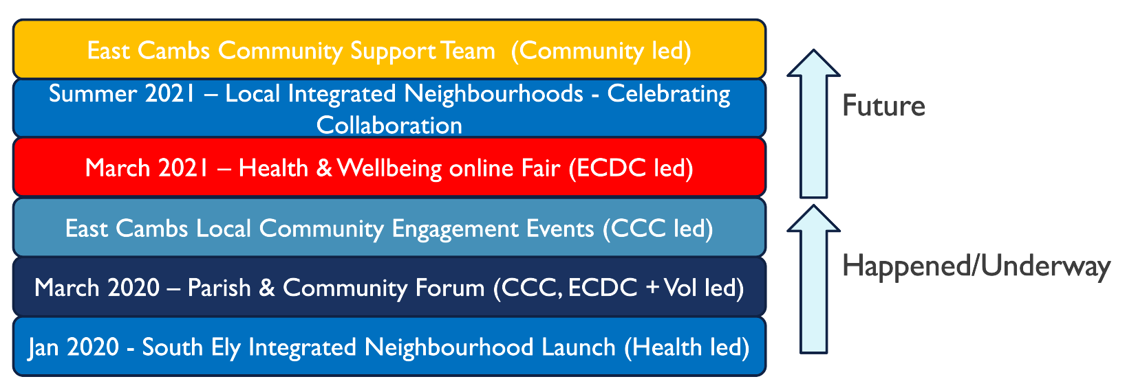
Fig1

Feedback from Group Discussions

Breakout 1 – Checking in on Key Themes
Communities agreed that the key themes which were shared are priorities locally ie
- Social Isolation​*
- Rising mental health issues (all ages)​*
- Digital Exclusion​
- New Economic Hardship* (often amongst people who have never experienced it)​
- Carers in crisis​*
- Supporting people to self-manage long term conditions
Those with * were emphasised. In addition the following were highlighted:
- Pre-empting future economic hardship and supporting people early.
- Develop methods of communication. And in relation to technology, not just access to tech but also skilling people up to using it.
- Concerns about gaps in education for young people and reduced prospects as a result of the pandemic. Also concern about returning to normal life post-pandemic
- Connecting people and opportunities – including the need to match volunteer’s skills with areas of the community that need those skills. Also building confidence.

Breakout 2 – Building collaboration
- Community led conversations and opportunities for sharing positive stories/initiatives
- Working across the system before considering further commissioned Health and social services e.g. collaboration between voluntary and community sector and social prescribers, community workers to connect people with their local community.
- Need for centralised information base but to be provided in various formats so as it can be used in ways most effective for specific community groups
- Sharing accountability through shared decision making with the community themselves
- Using public spaces / buildings more effectively.

Next Steps

The County Council East Cambs Local team will continue to work on:
- Developing a communications infrastructure to support shared learning including;
  - the East Cambs Local e-newsletter, with the suggested pdf of selected articles which can be used for noticeboards. Since the meeting Caline has published this edition.
  - The Parish and Community Forum – seeking feedback from communities on how we can develop it.
  - Developing Social media (see below)
- Community Mapping – The development of a database and map was felt to be useful, importantly it needs to link with/build on other similar resources such as Ely i. Chris is working on developing this. Groups and Organisations who would like to feature on the map and database need to fill in this form.
- Work with partners on the emerging themes (see Breakout 1). Please do get in touch if you have ideas for this – wendy.lansdown@cambridgeshire.gov.uk
Attendees agreed that it would be useful to meet up again in the summer.

Please stay in touch:
@EastCambsLocal @CambsEast
sign up to East Cambs Local newsletter

